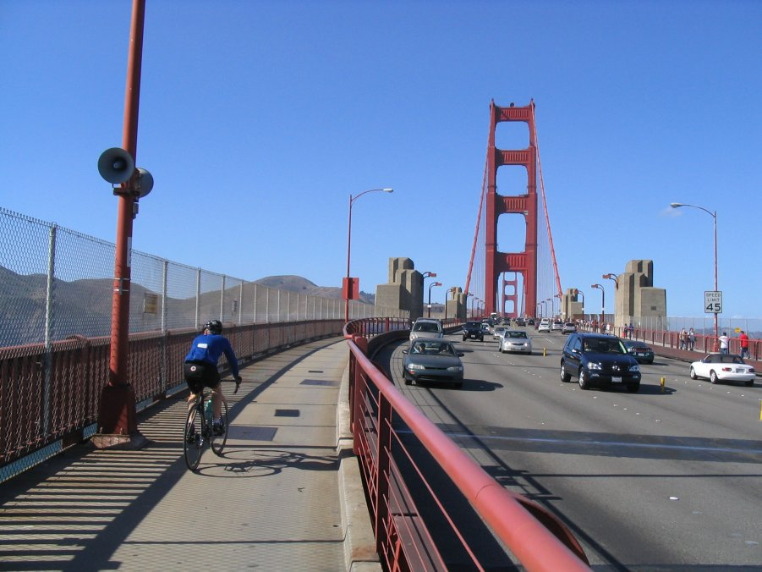
Bike to Work Week
May 11th -15th, 2009

Photo: Roger Wendell @ www.rogerwendell.com

Join millions of commuters around the nation as they participate in Bike to Work Week promoting bicycling as an alternative method of transportation. You're invited and encouraged to walk or bike to work at least one day during May 11-15th!

For those interested in BIKE LOCKERS twenty new lockers are expected to be ready for distribution in 4-6 weeks. Current lockers are being evaluated for use and re-keyed for increased security and ease of access.
For more information on bike lockers, please contact John Comstock at x 2441


15th Annual Bike to Work Day - Thursday, May 14th,

The San Francisco Bay Area's 15th Annual Bike to Work Day will take place on Thursday, May 14, 2009. Bike to Work Day is the premier bicycling event taking place in all of Northern California with all nine Bay Area counties participating in the celebration. For more event information visit www.btwd.bayareabikes.org

